**CoogSoft 2nd Gameplay Test Document**

**1314 Shadowbrook St - The Others**

**Fun Factor:**

* Same points from last time, except the timer being too fast
* Not sure what the Special attribute means on the gear
  + 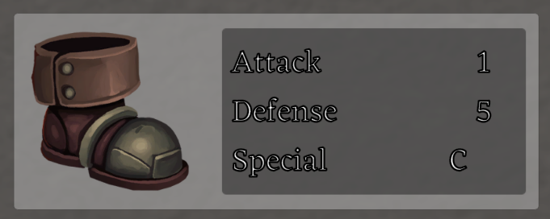
* Lots of new features added and rooms polished, making the game feel more refreshing
* The Main menu sets the mood for the game with the blurry background and spooky creeping music
* Mouse is replaced with a ghost

**Glitches/Issues:**

* When returning to main hallway, the doors don't have a triangle above them (or can not see them)
* 8 seconds is way too fast, doesn’t give enough time to reroll and plan your spells
* Button for fireplace interaction “Pick up the coin and the axe” text overflows
* Shop Exit button should be like the inventory Exit button (make the X on top transparent)
* When in shop and clicking on the screen, if you press space, it opens the dialogue box behind the bag menu
* when you click the bag if you just keep pressing space it will glitch which gives you a bunch of the same spells and a bunch of the items1 newspapers
  + 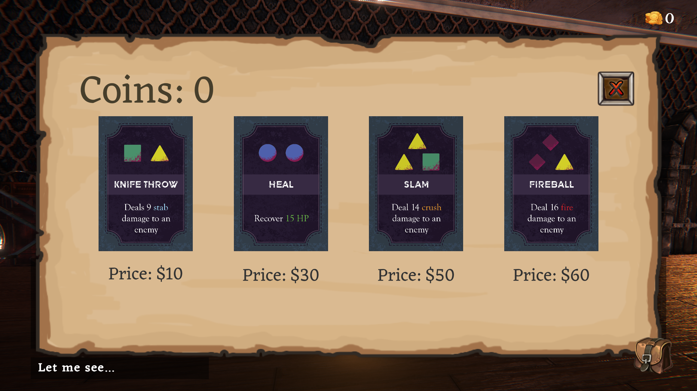
* Still a little buggy to get up the stairs outside while moving. I have to jump standing still then at the highest point move left.
* Fall out of hallway when moving left
  + 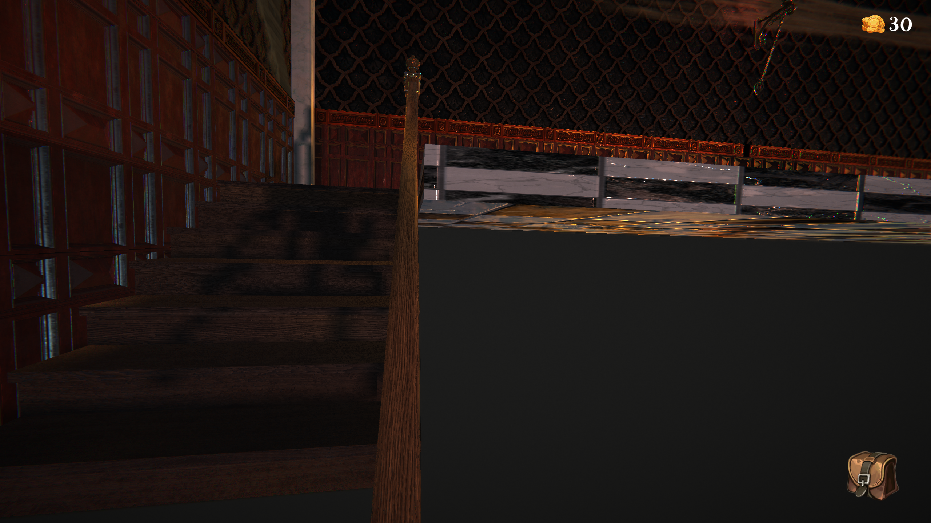
* PUZZLES: After solving the picture puzzle, nothing happens. Combination lock puzzle is solvable twice and both times it says STUN unlocked
* [Jumping Loop Video](https://drive.google.com/file/d/14kLLaxnTR9efgCoOqxfV8fD932onDyhx/view?usp=sharing)
  + While holding the jump button, if you move the character, the character will still perform the jumping animation while moving, until you let go of the jump button
* Minor UI issues
  + 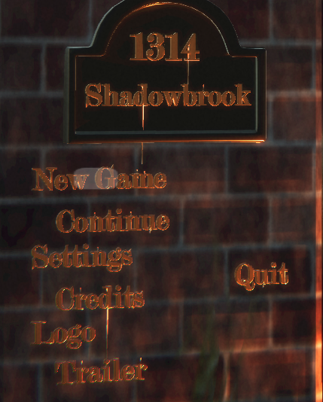
    - The selection bar does not cover all of the “New Game” text (also continue)
  + 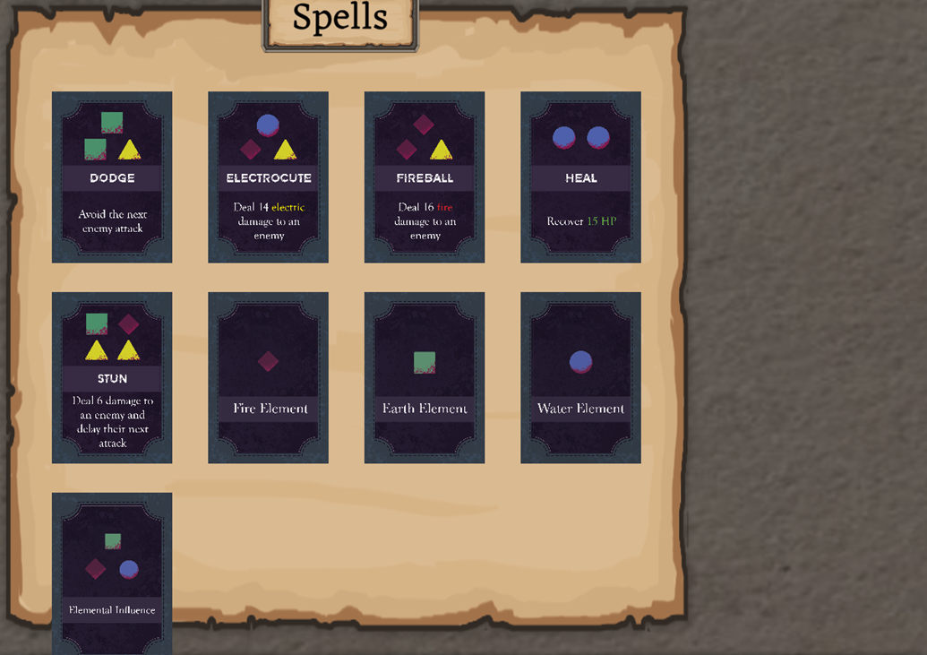
    - The spells on the 3rd row will start to overflow off of the spells map
  + 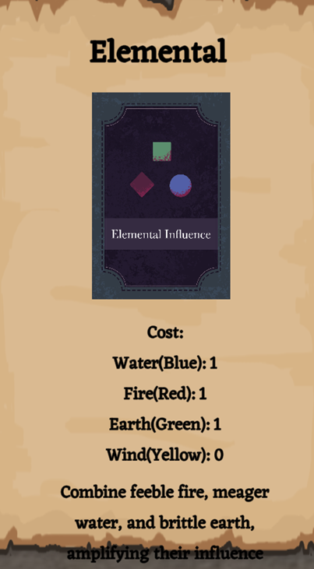
    - Description for the Elemental Influence spell overflows off of the spells map
    - The title of this spell only says “Elemental” instead of “Elemental Influence”
  + Couldn’t screenshot in time, but the inventory bag covers some of the text in the end cutscene (suggestion: hide the inventory bag during cutscene)
  + The gear stats show up in the player stats, but the icons disappeared after quitting and relaunching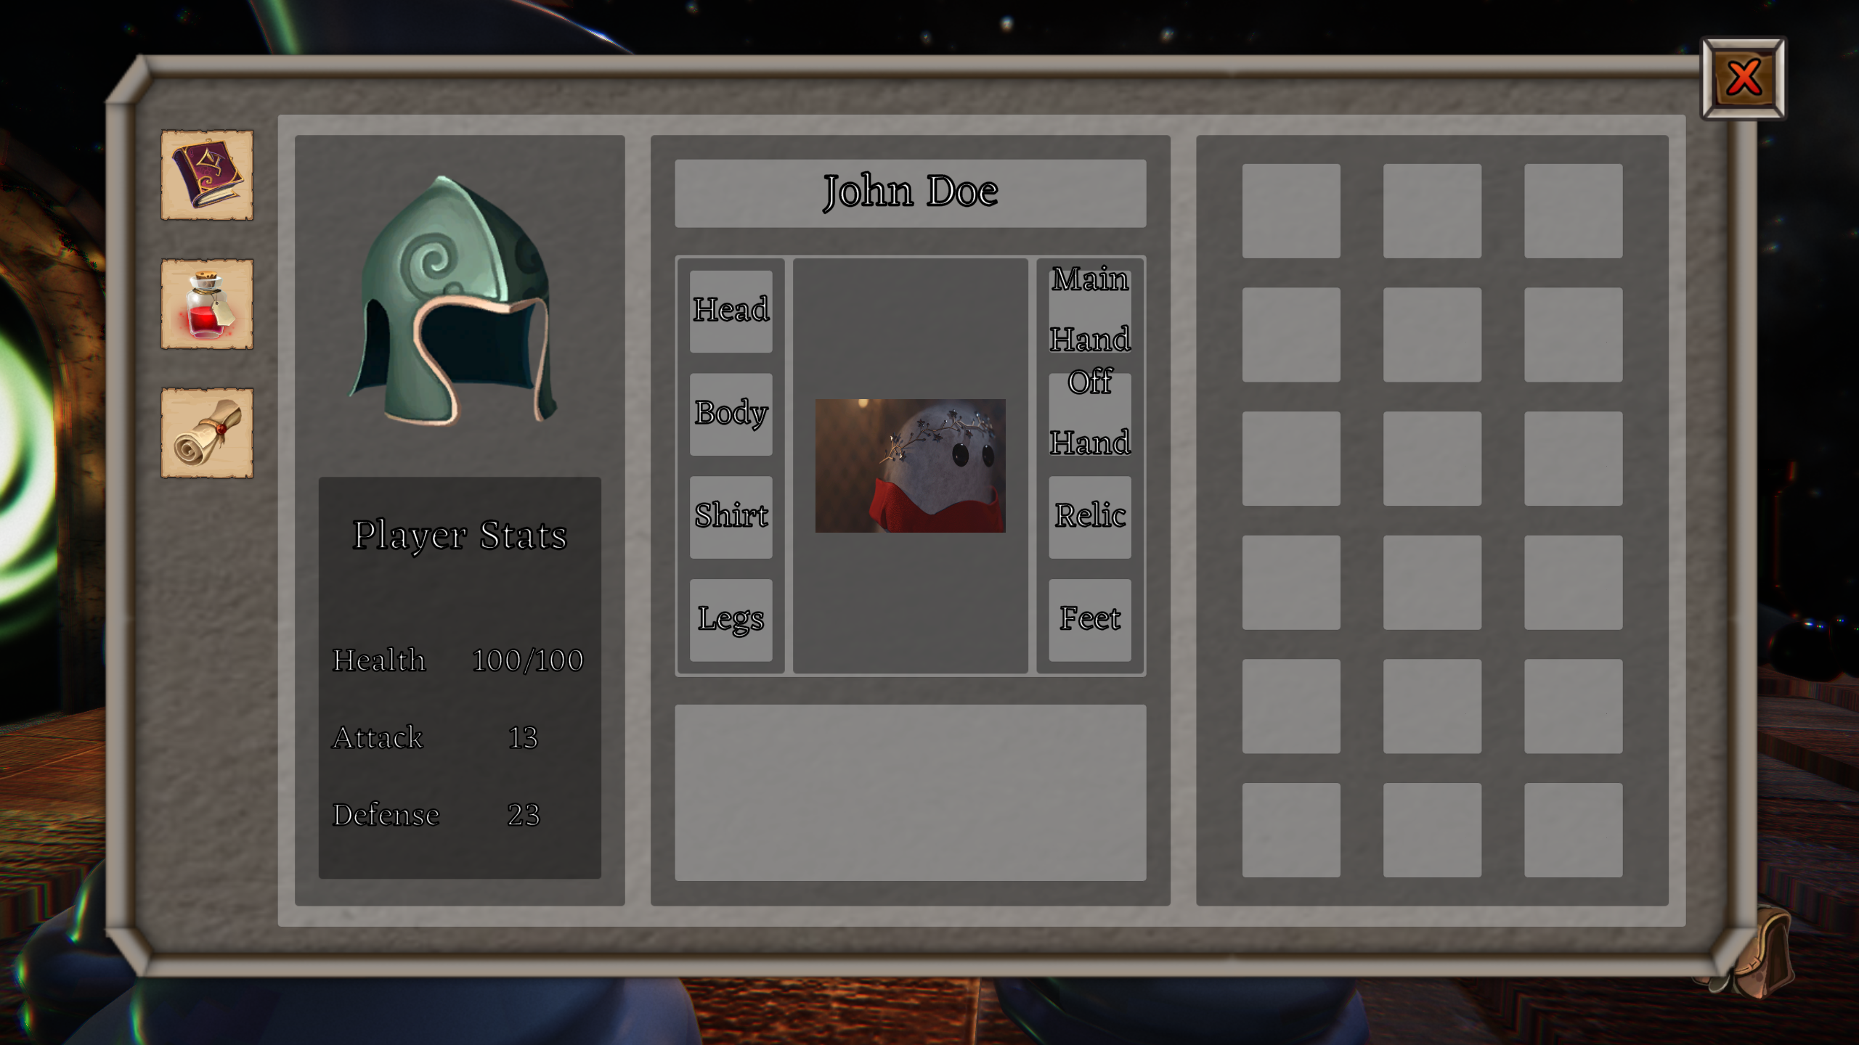

**Suggestions:**

* The main menu buttons don’t cover the whole text
* When coin +[num], there should be an audio cue
* Add the letter “I” over the bag to show the key needed to use it
* After solving the clock time puzzle, should no longer show the yellow interactable triangle
* The boss can be a bit overbearing. For the second spells bag you come across right before the boss, maybe add a “Heal+” spell?
  + This spell could replace the current Heal spell automatically (if the player already owns it), and obviously require a little more material to use. In exchange, this spell would heal the player more
* Somehow show who is talking in the dialogue, it’s hard to tell sometimes if the ghost is talking to himself or if it’s the thing he interacts with
* Rook covers up most of the screen when interacting with boss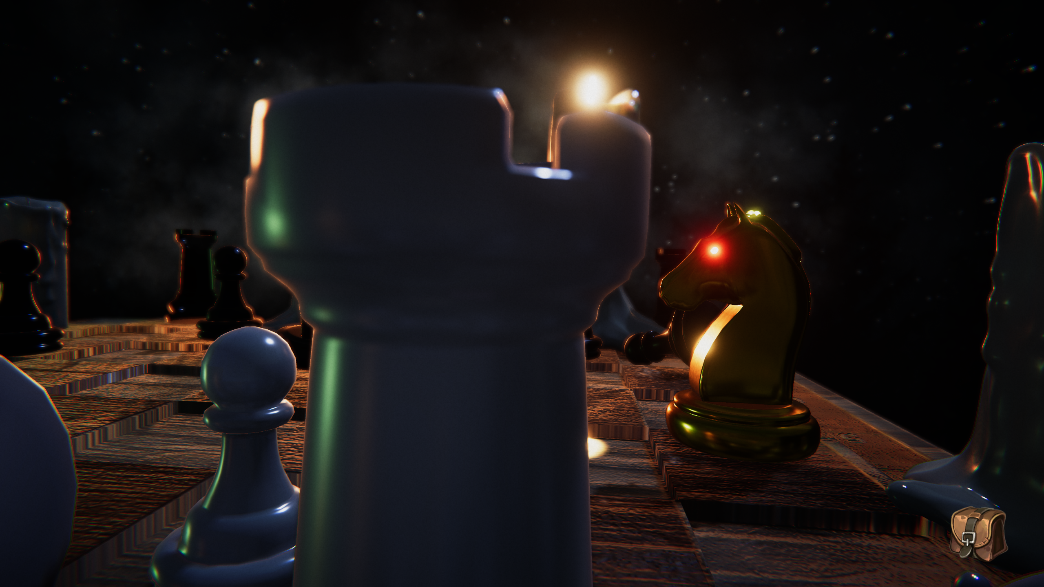
* Have a place on the combat screen that shows the current cards you have selected and how many of them